**Mr. Visca’s: Calculus (Chpt 2.2)**

**Chpt 2 – Day 4 Limits Involving ∞**

**Finite Limits as x approaches +/- infinity**

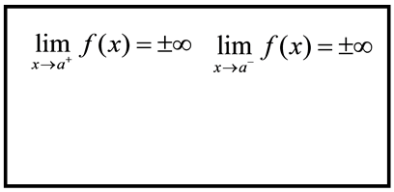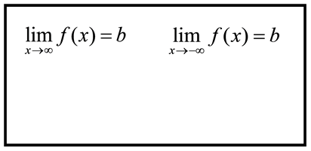

____________________________ ____________________________

*  ___________________________
* 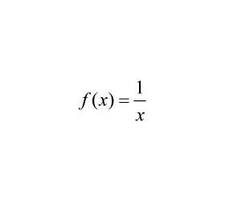 ___________________________
* ___________________________

Find all vertical and horizontal asymptotes using limits for the function,

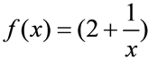Find all vertical and horizontal asymptotes using limits for the function,

(interesting fact: properties of limits also applies when x --> ±∞)

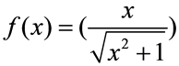

Find all vertical and horizontal asymptotes using limits for the function,

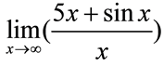

Using the properties of limits, find the limit:

Describe where all the vertical asymptotes would fall for f(x) = tan (x)

*HW: Sec 2.2*

*#s 1-7 odd, 13-19 odd, 27, 29, 31*